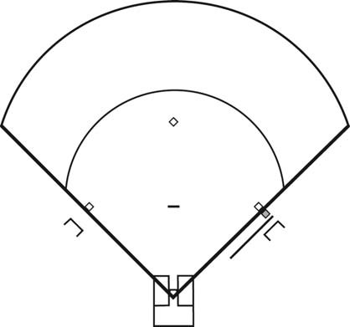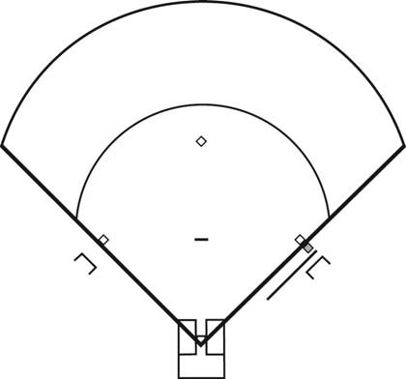

PRACTICE PLAN # |  |  |  |  |  | DATE:
Location: |  |  | # of Athletes: |  |  |  | Length of Practice
Absent Athletes:
Support Staff:
Goals of Practice: | 1 | 2 |  |  |  |  | 3
INTRO
Use the space below to outline what you will tell your athletes at the start of practice:
WARM‐UP
DRILL:
Time:
Equipment:
Objective(s) of Drill:

Drill Description:

Key Teaching Points:

DRILL:
Time:
Equipment: Objective(s) of Drill:

Drill Description:

Key Teaching Points:

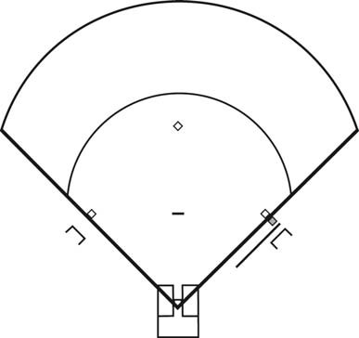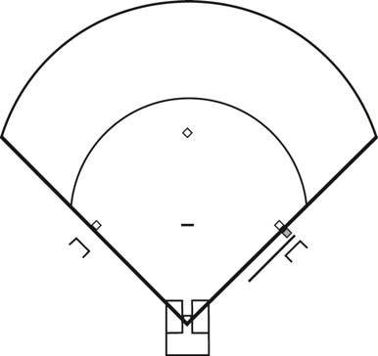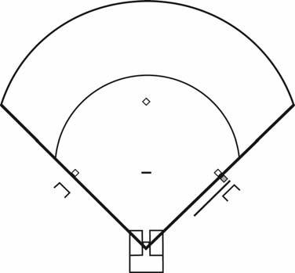
DRILL:
Time:
Equipment: Objective(s) of Drill:

Drill Description:

Key Teaching Points:

DRILL:
Time:
Equipment: Objective(s) of Drill:

Drill Description:

Key Teaching Points:

MAIN PART
DRILL:
Time:
Equipment: Objective(s) of Drill:

Drill Description:

Key Teaching Points:

DRILL:
Time:
Equipment: Objective(s) of Drill:

Drill Description:

Key Teaching Points:

DRILL:
Time:
Equipment: Objective(s) of Drill:

Drill Description:

Key Teaching Points:

DRILL:
Time:
Equipment: Objective(s) of Drill:

Drill Description:

Key Teaching Points:

DRILL:
Time:
Equipment:
Objective(s) of Drill:
Drill Description:
Key Teaching Points:
1
2
3
DRILL:
Time:
Equipment:
Objective(s) of Drill:
Drill Description:
Key Teaching Points:
1
2
3
COOL DOWN & CONCLUSION
10 minutes | Static Stretching Routine  Debrief:
PRACTICE EVALUATION
What worked well: |  | What to change for next time:

