Attach allergy/medical and emergency contact information for team members and coaching staff.

Emergency Numbers: | 9-1-1 (if available in your community)
Coach Information: | Head Coach: S. Good  Cell: (xxx) 987-6543 | Assistant Coach: H. Brown  Cell: (xxx) 456-7890
Home Facility: | Tel: (xxx) 123-4567  Address: Kay Arena  99 Wynwood Drive  Moncton, NB  Nearest Major Intersection:  Shediac Road and Kenmore Drive | Map: 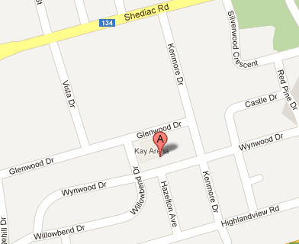
Nearest Hospital: | Tel: (xxx) 555-5555  Address: The Moncton Hospital  135 MacBeath Avenue  Moncton, NB | Map: 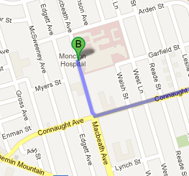
On-site Charge Person(s)  - Clear the risk of further harm to the injured person by securing the area and shelter the injured person from the elements  - Designate who is in charge of the other players  - Protect yourself (wears gloves if in contact with body fluids such as blood)  - Assess ABCs (checks that airway is clear, breathing is present, a pulse is present, and there is no major bleeding)  - Wait by the injured person until EMS arrives and the injured person is transported  - Fill in an accident report form |  |  | Option 1: S. Good  Option 2: R. Good  Option 3: T. Green
On-site Call Person(s)  - Call for emergency help  - Provide all necessary information to dispatch (e.g., facility location, nature of injury, what, if any, first aid has been done)  - Clear any traffic from the entrance/access road before ambulance arrives  - Wait by the driveway entrance to the facility to direct the ambulance when it arrives  - Call the emergency contact person listed on the injured person’s medical profile |  |  | Option 1: H. Brown  Option 2: V. Smith  Option 3: B. Whiting

